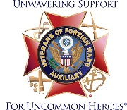
Department of Maryland Auxiliary to the
Veterans of Foreign Wars of the United States

General Orders No. 2 – August 2024

These General Orders are to be read at the first meeting following receipt before being filed for reference:

- The next Council of Administration meeting will take place at 12:00 noon on September 22, 2024 at VFW Post 652, 30922 River Road, Millington, MD 21651.

- Make sure your Auxiliary and Post are bonded by August 31, 2024.

- In accordance with Article VIII, Section 814C, pages 86-87, Para 4 of the National Bylaws, the Third Quarter Audit covers the months of July, August, and September and shall be conducted during the month of October. A copy of this audit must be mailed to the Department Treasurer no later than October 30.

- Hospital Treat and Hospital Fund donations should be sent to the Department Treasurer Jackie Kimball, PDP at 1019 Queen Avenue, Salisbury, MD 21801 as soon as possible so that the Hospital Chairman Cynthia Davis can prepare for our Christmas visits at the VA Hospitals.

- The annual “Celebrating America’s Freedom Event” (CAFÉ) will be held in Lansing, MI at The National Home on September 7, 2024. If you need any additional information, please contact the Department Secretary Libby Dalla Tezza.

- The VFW Auxiliary National President Brenda Bryant will be visiting Maryland on September 19 – 21. We plan to visit my Special Project Patriot Point in Madison, MD. We are trying to organize a picnic lunch with them and plan to visit the Harriett Tubman National Park in Church Creek, MD. More information will follow.

- All members please sign in to your MALTA account and go to “Manage Profile” where you can verify or update your contact information.

BY ORDER OF:
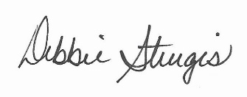

Deborah “Debbie” Sturgis
Department President

